**Project Design Phase-II**

**Technology Stack (Architecture & Stack)**

|  |  |
| --- | --- |
| Date | 21 June 2025 |
| Team ID | LTVIP2025TMID60007 |
| Project Name | Health AI-Intelligent Healthcare Assistant Using IBM Granite |
| Maximum Marks | 4 Marks |

**Technical Architecture:**

A healthcare assistant’s technical architecture typically involves a combination of software and hardware components designed to support various tasks like patient monitoring, communication and data management. This architecture should be scalable, interoperable and reliable, ensuring efficient and safe healthcare delivery.

**Example: Order processing during pandemics for offline mode**

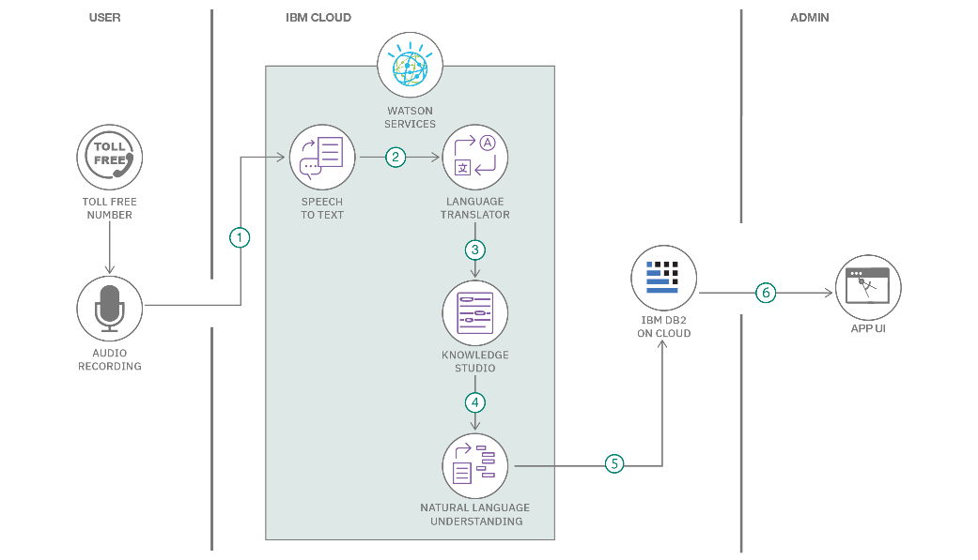

Guidelines:

* Incorporating all relevant processes as either application logic or technology blocks.
* Emphasises clearly defining the boundaries .
* Specifies all data storage components and services used in the system.
* Machine learning models are integrated and their interfaces must be clearly indicated.
* Requires identifying and documenting any interfaces that interact with external systems such as third-party APIs.

**Table-1 : Components & Technologies:**

|  |  |  |  |
| --- | --- | --- | --- |
| **S.No** | **Component** | **Description** | **Technology** |
|  | User Interface | How patients or healthcare professionals interact with AI applications | Web UI, Mobile apps, Chatbots, voice assistants |
|  | Application Logic-1 | Logic for core processes in health AI applications | Java , Python |
|  | Application Logic-2 | Logic for integrating specialized AI services in healthcare | IBM Watson Health, Google cloud healthcare API |
|  | Application Logic-3 | Logic for AI-driven patient engagement and support | IBM Watson Assistant , Google dialogflow, specialized AI engines |
|  | Database | Storage of diverse healthcare data | SQL databases, NoSQL databases |
|  | Cloud Database | Scalable and secure storage for large-scale healthcare datasets in the cloud | IBM DB2 on cloud, google cloud healthcare API |
|  | File Storage | Requirements for storing large files like medical images, large datasets | Cloud storage, google cloud |
|  | External API-1 | Purpose of External APIs for integrating health data or services | FHIR APIs, HL7 APIs, APIs for medical device integration |
|  | External API-2 | Purpose of External APIs for specialized AI services or external data sources | APIs for drug-drug interaction, clinical trail data APIs |
|  | Machine Learning Model | Purpose of Machine Learning Models in healthcare such as disease diagnosis | Deep learning models, predictive models |
|  | Infrastructure (Server / Cloud) | Deployment environment for health AI applications | Secure cloud platforms, Edge computing for real-time device data processing |

**Table-2: Application Characteristics:**

| **S.No** | **Characteristics** | **Description** | **Technology** |
| --- | --- | --- | --- |
|  | Open-Source Frameworks | Machine learning libraries, deep learning frameworks or data processing tools | TensorFlow, Apache Spark, Hugging Face Transformers |
|  | Security Implementations | Protect sensitive health data and ensure compliance with regulations | IAM Controls, AES-256, Secure Multi-Party Computation |
|  | Scalable Architecture | It can handle increasing data volumes and user loads in a health AI context | Microservices architecture, Cloud platforms, API Gateways |
|  | Availability | Ensures continuous operation and access to critical health services also includes load balancing, distributed servers, and disaster recovery | Load balancers(AWS, ELB), Distributed databases, Geo-redundant storage |
|  | Performance | Responsiveness, processing speed for large datasets and efficient resource utilization | Caching mechanisms, Content Delivery Networks for static content, Asynchronous processing queues |